2X8D Sequencer Performance Specification
A Eurorack Synthesizer Module

The 2X8D Sequencer is a digital EuroRack version of the MFOS Ten Step Analog Sequencer with more features. There are two 8 step sequencers than can instead be operated as one 16 step sequencer. The below table should give a sense of its features.

Signal Description
This table describes the signals connected to UI elements on the face plate.
# | Signal Name | UI Element | Voltage Range | Signal Description
Step Specific UI
1 | Step Indicator | LED | - | Turns on when its step is active. If its step select is off, the LED doesn’t turn on.
2 | Step Select | Toggle Switch | - | Turn on to insert this step into the sequence. If on then CV, gate, and trigger outputs are generated for this step.
3 | CV Level | Pot | - | Controls the CV Out voltage value during this step.
Inputs
4 | Sequence Length | SP8T Rotary Switch | - | Selects the last step in the sequence. Can set from 1 to 8. If set to 6, the 6th step is the last one in the sequence. Then the sequence either stops or resets.
5 | Running Direction | 3 Position Toggle Switch | - | Outputs the sequence going forward, backward, or randomly. One for each channel.
6 | Octave | SP10T Rotary Switch | - | The CV Level pots will only sweep through 3 octaves at once. This switch selects the octave that the pot starts at. One for each channel. Really only need 9 positions, but 10 position switches are more common.
7 | Clock Rate | Coarse Pot and Fine Pot | - | How fast the sequence changes steps. In other words, the number of seconds each note is played before changing to the next one. Fine pot is 10 times as sensitive as Coarse pot.
8 | Clock Multiplier | SP8T Rotary Switch | - | Has settings 1/8, 1/4, 1/2, 1, 2, 4, 8, 16  In series mode: Unsure. Multiplies what was set by Clock Rate.  In parallel mode: Affects the B sequencer clock rate based on the A sequencer clock rate, which can be from either an internal or external source.
9 | Step | Push Button | - | Moves the sequence to the next step. Useful when paused and programming it. Affected by Running Direction.
10 | Pause | Push Button | - | Clicking causes the sequencer to pause. Clicking again causes it to start.
11 | Gate Width | Pot | - | Lets the gate signal not last the entire length of the note, which lets an ADSR fed by the Gate signal to drop off before the end of the note.
12 | Exact Notes | Toggle Switch | - | When on, CV outputs will round to the nearest proper note based on 1V/octave.
13 | Exact Time | Toggle Switch | - | When on, Clock Rate will change by 1/8? second increments. Chose this value when testing.
14 | External Clock | Jack | 0V - 5V | Synchronizes the output to an external clock. Can probably do this in software with interrupts?
15 | Series/Parallel Select | Toggle Switch | - | Configure the sequencer as either two 8 step sequencers (A and B), or a single 16 step sequencer.
16 | Stop/Repeat Sequence | Toggle Switch | - | Stop: When the sequence is at the end, stop it. Needs to assert Reset to play again.  Repeat: when the sequence is at the end, start again from the beginning.
17 | Reset | Push Button and Jack | 0V - 5V | Starts playing the sequence from the first step.
18 | CV Polarity | Toggle Switch | - | Switch between outputting ±5 V or 0-10 V CVs. Testing might change the unipolar setting to 0-5 V.
19 | Portamento Rate | Pot | - | Controls how fast the voltage from Portamento Out changes. Not connected to the uC. Done in hardware.
Outputs
20 | CV Out | Jack | ±5V | Outputs a voltage that changes each step based on CV Level. 1V/octave. If Step Select is off it still outputs the note given by CV Level.  One for each 8 step sequence. In series mode they output the same voltage. See the appendix for voltage values.
21 | Portamento Out | Jack | ±5V | Same as CV Out, but the CV slides between the last output level and the next one. This is done outside the microcontroller.
22 | Trig Out | Jack | 0 - 5V | Goes high for every active step for a very short time, something like 10 ms. Stays at 0 V if Step Select is off.
23 | Gate Out | Jack | 0 - 5V | Stays high until a step is not active. The Gate Width control lets it not last the entire note length. Stays at 0 V if Step Select is off.

Portamento Description

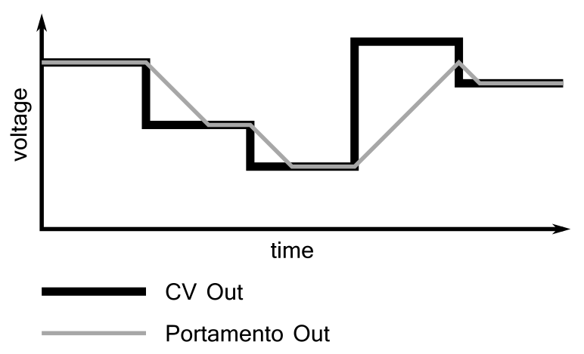

The Portamento Out output follows the CV Out output, but is limited to a certain slew rate. If Portamento Out doesn’t reach the CV Out level before it changes again, Portamento Out starts moving towards the new output level. The slew rate is adjusted by the Portamento Rate knob. The “slew shape” isn’t necessarily linear. It could be exponential or some other shape.

Block Diagram

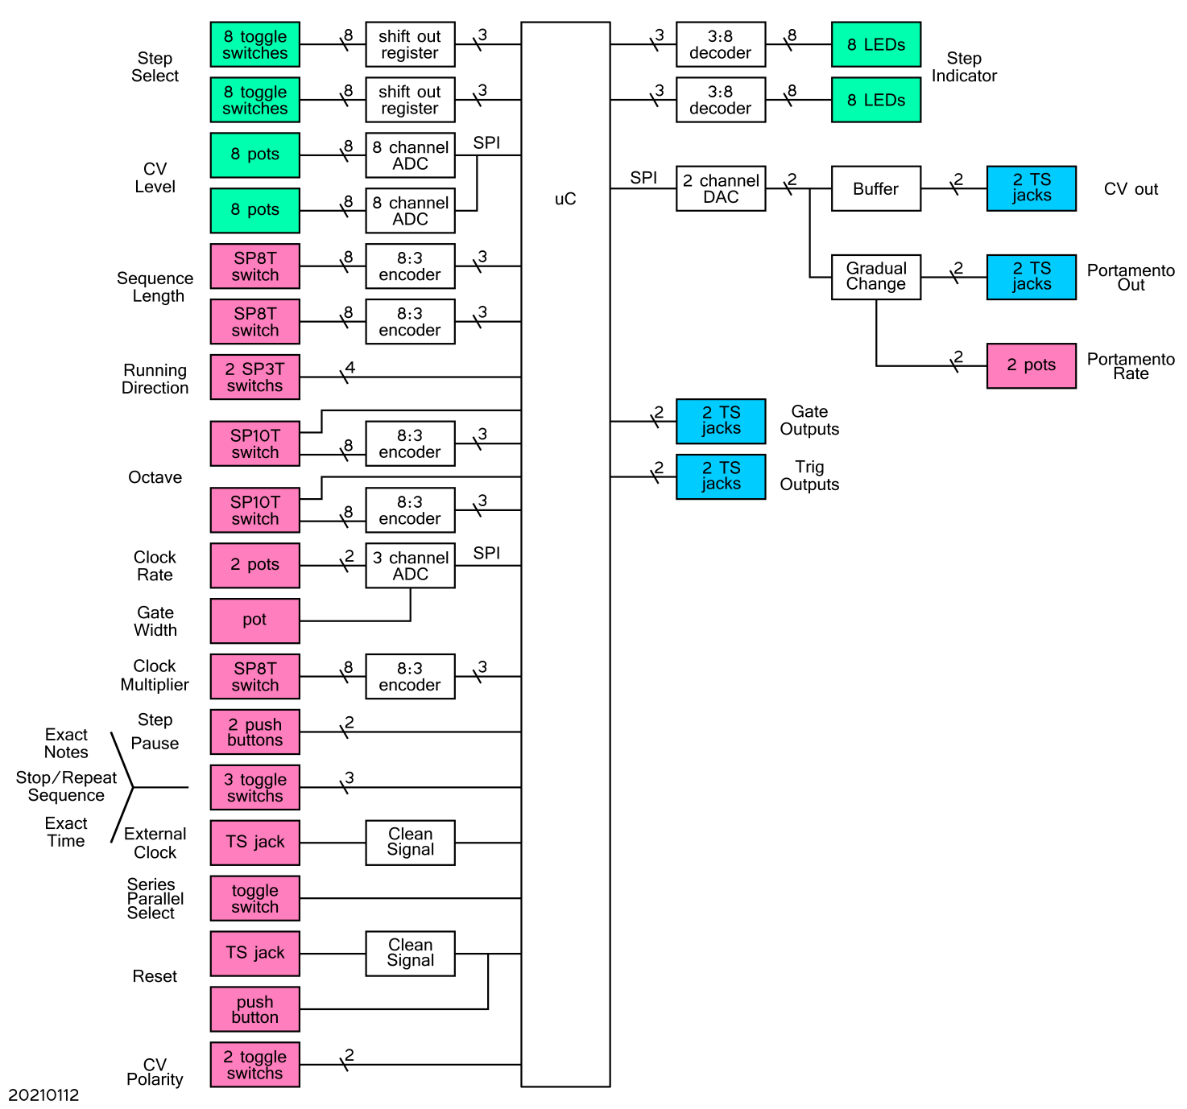

For the Clock Rate pots, instead of reading each pot individually, I might connect them in series then just read the final output voltage. This would be faster (one ADC read instead of two) and would reduce the requirement from a 3 channel to a 2 channel ADC, but it also might make tuning the clock rate jumpy or less sensitive.

Power
EuroRack provides 5 V and ±12 V rails. The microcontroller might require a 3.3 V rail, which can be provided by a linear regulator from the 5 V rail.
Rough Face Plate Layout
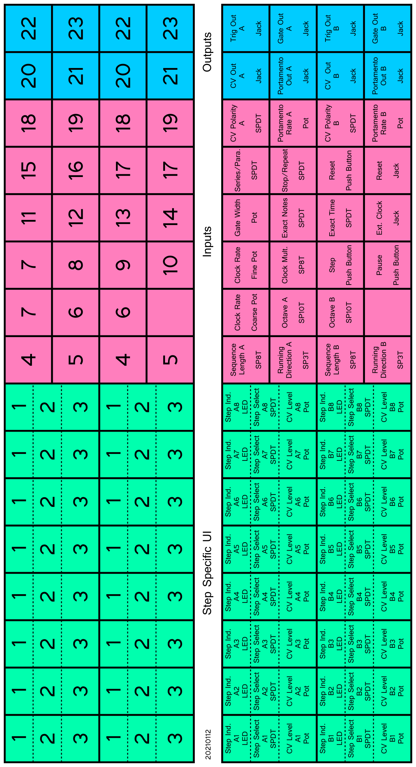
UI component position may change based on component size, logical grouping, or needing to put components of similar height together in order to be soldered to the same PCB. They also don’t need to be in a grid pattern.

Microcontroller Behaviour
A lot of the controls can be read when the microcontroller needs them. However, some controls require the microcontroller to react to the immediately (bold entries in the following table).

Also, some behaviour could be different depending on if the sequence is paused (and the user is presumably tuning a step) or if it’s running. If you’re tuning the CV, the ADC should read just the current CV Level pot continuously.

The following table should be used to make block diagrams that define what the microcontroller does during each step.

# | Signal Name | UI Element | How Microcontroller Interfaces
Step Specific UI
1 | Step Indicator | LED | uC turns on the LEDs when needed.
2 | Step Select | TS | During each step, uC reads the Step Select switch for the next step. If off, read the next step after that. Continue until you find a step that’s on. Although given that all the switch data is shifted into the uC at once, individual reading for each switch aren’t needed.
3 | CV Level | Pot | The next step’s value is read during the previous step so it’s ready to go when needed.
Inputs
4 | Sequence Length | SP8T | Read every step.
5 | Running Direction | 3 Position TS | Read at the start of either sequence.
6 | Octave | SP10T | Read every step.
7 | Clock Rate | 2x Pot | Read every step. There needs to be a “lock in” feature, so each time the ADC is read, a slightly different value isn’t used. This would cause the timing to drift over time. Maybe values within 2% of the previous value are ignored? That might cause fine tuning to be annoying, but that might be fixed by the Fine pot? Solve this problem during testing and see what feels good.
8 | Clock Multiplier | SP8T | Read every step.
9 | Step | PB | uC reacts immediately when asserted.
10 | Pause | PB | uC reacts immediately when asserted.
11 | Gate Width | Pot | Read every step.
12 | Exact Notes | TS | Read every step.
13 | Exact Time | TS | Read every step.
14 | Ext. Clock | Jack | uC reacts immediately when asserted.
15 | Series/Parallel | TS | Read every step.
16 | Stop/Repeat | TS | Read at the end of either sequence.
17 | Reset | PB + Jack | uC reacts immediately when asserted.
18 | CV Polarity | TS | uC reacts immediately when switched. It might be possible to not involve the microcontroller in this function.
19 | Port. Rate | Pot | Not connected to microcontroller.
Outputs
20 | CV Out | Jack | Microcontroller programs the DAC at the start of every step.
21 | Port. Out | Jack | Not connected to microcontroller.
22 | Trig Out | Jack | Microcontroller changes the GPIO as needed during each step.
23 | Gate Out | Jack | Microcontroller changes the GPIO as needed during each step.

Notes
Input Voltage Tolerance
All inputs must tolerate -12 to +12 V input signals without distorting the signal. i.e. if you plug a 12V trigger signal into the Reset input, the trigger signal must still go up to 12V, not saturate at 5V.

Practically, there’s only two voltage inputs, both digital: Reset and External Clock. They could be fed through an input buffer schmitt trigger connected to the ±12 V rails, then voltage dividing the output down to a voltage the microcontroller can handle.

Input and Output Impedance
From https://learningmodular.com/glossary/impedance/
Eurorack modules tend to have an input impedance of 100 kΩ; output impedances can vary from near zero to 1k.

Here I think I’ll follow the MFOS sequencer and use a 220 Ω resistor in series with each output. At 12V this gives a current of 55 mA when the output is shorted to ground. (Make sure outputs are rated to at least 55 mA or increase output resistance). When fed into an input impedance of 100 kΩ, 99.8% of the voltage will be across the input impedance.

https://www.muffwiggler.com/forum/viewtopic.php?t=12112
This forum thread claims output impedances are usually 1 kΩ, which gives 12 mA at 12 V shorted to ground.

CV Level Sweep Range
The sweep range is the range of notes your can tune to by turning a CV Level pot over its full rotation range.

The MIDI range is 128 notes. The CV Level pots have a rotation range of 300°. Making the CV Level pot sweep range all 128 notes would give 2.34°/note, which is quite small:

To tune multiple steps to the same note, multiple pots would have to be turned to somewhere in that angle, which seems difficult. Most songs have a range under 3 octaves, or 36 “notes” (including sharps/flats). For 300° of pot rotation, that gives 8.33°/note, which seems more manageable:



CV Level ADC Bit Depth
From above, each CV Level pot will sweep over 36 notes. An ADC that takes samples of 6 bits can read 64 different states. However it’s probably useful to be able to play frequencies between the notes. 12 bit ADCs are very common and I’ve found a few cheap ones recommended on synth forums. 12 bits gives 4096 states. For 36 notes, that’s 4096/36 = 113 states/note, which is better than 1% increments of each note. That’s probably good enough.

Total Octave Range
The MIDI range covers octaves -1 to 9, or 11 octaves. The CV Level pots will be able to access 3 of them at once. The Octave switch will be able to select the lowest octave available, letting the CV Level pots tune to that octave and the next two highest.

Given that, the Octave switch needs to have 9 positions. When in the first position the CV Level pots will sweep through octaves -1 to 1. When in the ninth position the CV Level pots will sweep through octaves 7 – 9.

It’s easy to get 10 or 12 position switches like this one from Tayda Electronics for $0.89:

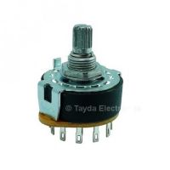

With that particular switch, a larger knob is needed to hide the anti-rotation stub that goes through the face plate. I ordered a sample and its “switch feel” is pretty good.

Interfacing the Octave Switch to the Microcontroller
Option 1: 8:3 Encoder
I’m using 8:3 encoders in a few other places and could use one to connect the switch to the microcontroller. This would entail losing one of the switch positions and only covering 10 of the MIDI octaves. Looking at the MIDI chart in the Appendix, I’d rather have a range of (16.35 Hz – 12.5 kHz) than (8.18 Hz – 7.9 kHz). So I’d cover octaves 0 – 9.

Option 1: 8:3 Encoder + 1 GPIO
As above, but I could connect the ninth switch position to another GPIO.

Switch Position | GPIO 4 | GPIO from Encoder
Switch Position | GPIO 4 | GPIO 3 | GPIO 2 | GPIO 1
1 | 0 | 0 | 0 | 0
2 | 0 | 0 | 0 | 1
3 | 0 | 0 | 1 | 0
4 | 0 | 0 | 1 | 1
5 | 0 | 1 | 0 | 0
6 | 0 | 1 | 0 | 1
7 | 0 | 1 | 1 | 0
8 | 0 | 1 | 1 | 1
9 | 1 | don’t care

Option 2: 16:4 Encoder
This one also uses 4 GPIO, but needs an IC that’s probably more expensive.

Construction
The mechanical stack up is face plate, then UI components, then UI component PCBs, then electronics PCBs. Stack up is similar to many modules on the market, including this Befaco Rampage:

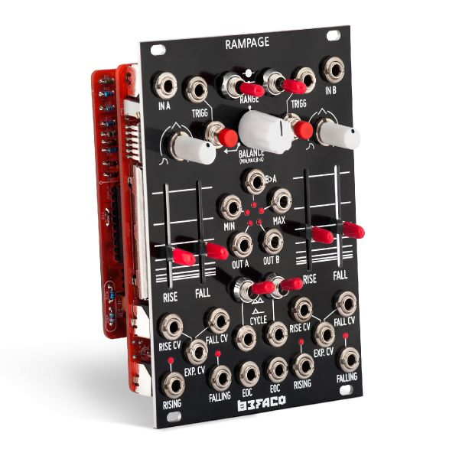

Design should enable replacing electronics very easily. In general, don’t put electrical components (ICs, caps, transistors, ect.) on UI component PCBs. Those PCBs are there to reduce soldering time. If the electronics on the UI component PCBs break then you’ll either have to unsolder all the UI hardware (time consuming) or buy new UI hardware (expensive).

On the face plate, put the individual step control stuff, then inputs, then outputs. Signal flow should go from left to right. This module will be in the top left of the rack, so this lets all the jacks be to the right to reduce cable length.

Maybe I can get pots with illuminated stems. Would have to use them with clear knobs, because turning just the pot stem doesn’t give fine enough control.

Very Rough Cost Estimate
Item | Cost
ICs | $35
UI Hardware | $30
PCBs – JLC PCB | $10
Import Fees – JLC PCB | $10
Per Unit Cost | $85

Appendix: Note Table
Partly derived from these sources:
https://pages.mtu.edu/~suits/notefreqs.html
https://www.inspiredacoustics.com/en/MIDI_note_numbers_and_center_frequencies

The notes corresponding to these voltage are what the design of the sequencer intends. However it’s very common to sum multiple voltages that are fed into an oscillator’s CV input, so programming a step to be a certain note will only play that note if the oscillator is configured correctly. This table’s primary use is to show the sequencer output range, and that it follows the 1V/octave standard. Grey values might be removed.

Note | MIDI Note # | Freq. [Hz] | Voltage [V]
Note | MIDI Note # | Freq. [Hz] | Bipolar | Unipolar
C-1 | 0 | 8.18 | -5.000 | 0.000
D-1 | 2 | 9.18 | -4.833 | 0.167
E-1 | 4 | 10.30 | -4.667 | 0.333
F-1 | 5 | 10.91 | -4.583 | 0.417
G-1 | 7 | 12.25 | -4.417 | 0.583
A-1 | 9 | 13.75 | -4.250 | 0.750
B-1 | 11 | 15.43 | -4.083 | 0.917
C0 | 12 | 16.35 | -4.000 | 1.000
D0 | 14 | 18.35 | -3.833 | 1.167
E0 | 16 | 20.60 | -3.667 | 1.333
F0 | 17 | 21.83 | -3.583 | 1.417
G0 | 19 | 24.50 | -3.417 | 1.583
A0 | 21 | 27.50 | -3.250 | 1.750
B0 | 23 | 30.87 | -3.083 | 1.917
C1 | 24 | 32.70 | -3.000 | 2.000
D1 | 26 | 36.71 | -2.833 | 2.167
E1 | 28 | 41.20 | -2.667 | 2.333
F1 | 29 | 43.65 | -2.583 | 2.417
G1 | 31 | 49.00 | -2.417 | 2.583
A1 | 33 | 55.00 | -2.250 | 2.750
B1 | 35 | 61.74 | -2.083 | 2.917
C2 | 36 | 65.41 | -2.000 | 3.000
D2 | 38 | 73.42 | -1.833 | 3.167
E2 | 40 | 82.41 | -1.667 | 3.333
F2 | 41 | 87.31 | -1.583 | 3.417
G2 | 43 | 98.00 | -1.417 | 3.583
A2 | 45 | 110.00 | -1.250 | 3.750
B2 | 47 | 123.47 | -1.083 | 3.917
C3 | 48 | 130.81 | -1.000 | 4.000
D3 | 50 | 146.83 | -0.833 | 4.167
E3 | 52 | 164.81 | -0.667 | 4.333
F3 | 53 | 174.61 | -0.583 | 4.417
G3 | 55 | 196.00 | -0.417 | 4.583
A3 | 57 | 220.00 | -0.250 | 4.750
B3 | 59 | 246.94 | -0.083 | 4.917
C4 | 60 | 261.63 | 0.000 | 5.000
D4 | 62 | 293.66 | 0.167 | 5.167
E4 | 64 | 329.63 | 0.333 | 5.333
F4 | 65 | 349.23 | 0.417 | 5.417
G4 | 67 | 392.00 | 0.583 | 5.583
A4 | 69 | 440.00 | 0.750 | 5.750
B4 | 71 | 493.88 | 0.917 | 5.917
C5 | 72 | 523.25 | 1.000 | 6.000
D5 | 74 | 587.33 | 1.167 | 6.167
E5 | 76 | 659.25 | 1.333 | 6.333
F5 | 77 | 698.46 | 1.417 | 6.417
G5 | 79 | 783.99 | 1.583 | 6.583
A5 | 81 | 880.00 | 1.750 | 6.750
B5 | 83 | 987.77 | 1.917 | 6.917
C6 | 84 | 1046.50 | 2.000 | 7.000
D6 | 86 | 1174.66 | 2.167 | 7.167
E6 | 88 | 1318.51 | 2.333 | 7.333
F6 | 89 | 1396.91 | 2.417 | 7.417
G6 | 91 | 1567.98 | 2.583 | 7.583
A6 | 93 | 1760.00 | 2.750 | 7.750
B6 | 95 | 1975.53 | 2.917 | 7.917
C7 | 96 | 2093.00 | 3.000 | 8.000
D7 | 98 | 2349.32 | 3.167 | 8.167
E7 | 100 | 2637.02 | 3.333 | 8.333
F7 | 101 | 2793.83 | 3.417 | 8.417
G7 | 103 | 3135.96 | 3.583 | 8.583
A7 | 105 | 3520.00 | 3.750 | 8.750
B7 | 107 | 3951.07 | 3.917 | 8.917
C8 | 108 | 4186.01 | 4.000 | 9.000
D8 | 110 | 4698.63 | 4.167 | 9.167
E8 | 112 | 5274.04 | 4.333 | 9.333
F8 | 113 | 5587.65 | 4.417 | 9.417
G8 | 115 | 6271.93 | 4.583 | 9.583
A8 | 117 | 7040.00 | 4.750 | 9.750
B8 | 119 | 7902.13 | 4.917 | 9.917
C9 | 120 | 8372.02 | 5.000 | 10.000
D9 | 122 | 9397.27
E9 | 124 | 10548.08
F9 | 125 | 11175.30
G9 | 127 | 12543.85

